# About Reports

The system provides automated Reports to simplify the reporting process.

Identified users are system administrators responsible for the daily operations that support the system’s transaction processing and who are familiar with Trade Innovation.

The system supports reports relating to the following:

* Daily Business Operations
* Departmental Limits
* Transaction Processing for Financing Transactions
* General Transaction Processing
* System Tailoring
* Watch List Checking
* License Compliance
* Export Definitions
* Instructions on Running Reports

# Business Operations Reports

This chapter covers reports relating to daily business operations. The following table lists these reports, showing for each which product group and category the report can be found under and the number of the page in this Guide on which it is described:

|  |  |  |
| --- | --- | --- |
| Report Title | Product Group | Category |
| Full Journal Report | General | Audit |
| Static/System Tailoring Changes | General | Audit |
| Overridden Event Warnings/Errors | General | Audit |
| Batch Steps Run | General | Audit |
| Diary Exceptions Report | General | Production management |
| Interface Details Report * | General | Interface |

* This report is intended for system administrators.

## Full Journal Report

This report lists entries from the journal file showing changes made to Trade Innovation system tailoring or static data. You can run the report for a single Trade Innovation user or all users, for a range of dates, and to show information for one or all of the following areas:

* Security
* System control
* Where Maker checker is being used, the Journal report can be used to select specific Maker checker areas, all Maker checker items or any Static/System tailoring and Maker checker maintenance items:
* Maker checker – zone
* Maker checker – customer
* Maker checker – branch
* Maker checker – all

Information is ordered by user within area, with entries for each user listed in chronological order. For each entry the report shows the following information:

* Details of what has changed, under the column *Type:*

|  |  |  |
| --- | --- | --- |
| External application | Maker checker – branch   * Account * Clearing System ID * Default nostro * Nostro * TI SWIFT detail | Maker checker – customer   * Account * Billing * Charge schedule * Charge schedule * Correspondent * Customer * Customer address * Customer expiry grace days * Finance percent/usance mapping * Group * Interest schedule * Reference block * Supply chain finance programme * TI customer details |
| Team/Banking entity map |
| Capability – Direct |
| Maker checker – zone:   * Account officer * Branch calendar * Charge schedule * Default days * Interest schedule * Service level type * Supply chain finance programme sub-type |

* One of the followings under column *Mode* to indicate whether the change involved is by creating new data or amending or deleting existing data:
* Add – a new item has been added
* Change – an existing item has been changed
* Delete – an existing item has been deleted
* The date and time the change was made
* Who has made the changeBefore and after images of the affected data, for updated items. For new (added) items, the 'before' image is unavailable, and for deleted items only the 'before' image is shown.

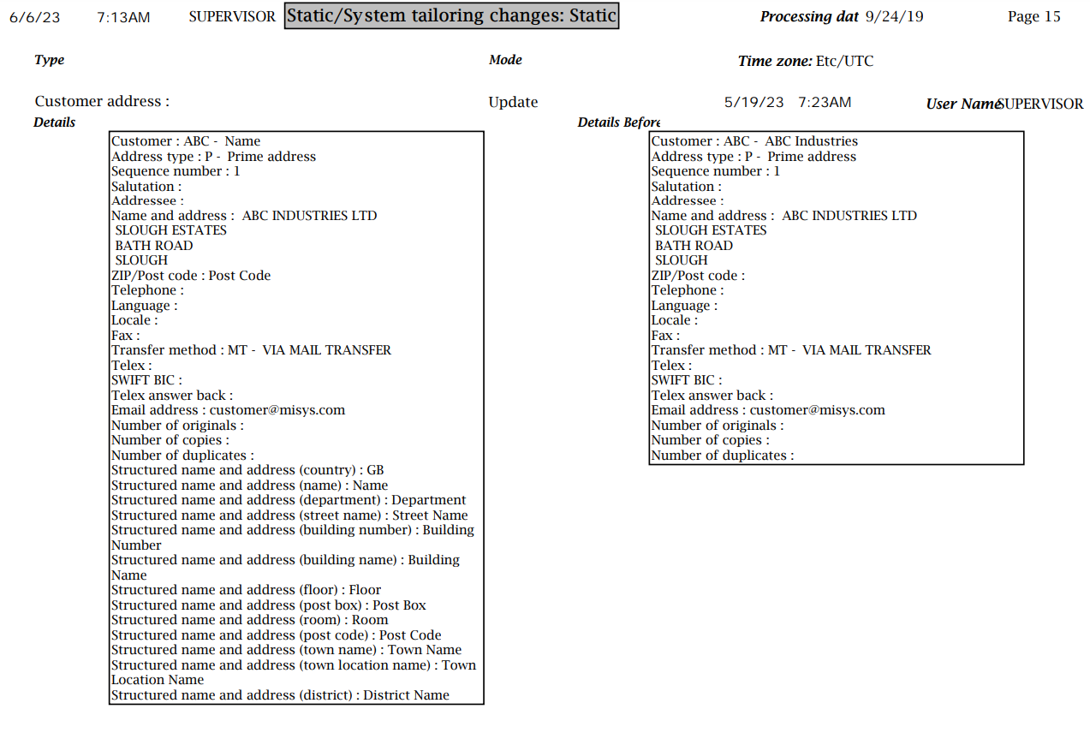

Where an item has been entered via Maker checker, the details of the Users approving or rejecting an item are reported:



Where the report is run to show changes to the capabilities of users or security groups, it shows the user or group affected, the capability, and whether it was added (Add) or removed (Delete). Where all capabilities have been added or deleted, the report indicates this and includes a single entry for all capabilities affected.

1. The following three reports are supplementary and show separately the contents of parts of the Full Journal Report.

## Static/System Tailoring Changes

This report lists entries from the journal file showing changes made to Trade Innovation system tailoring or static data. You can run the report for a single Trade Innovation user or all users, for a range of dates, and to show information for one or all of the following areas:

* Departmental Limits
* Process
* Static data
* SWIFT data
* Static/System tailoring/Maker checker
* Tailoring

For each entry the report shows the following information:

* Details of what has changed, under column *Type:*

|  |  |  |
| --- | --- | --- |
| Account | Event document map | Product group |
| Account officer | Event field check | Product group map |
| Account Special Instructions | Event field definition item | Product options |
| Account type | Event group | Product tracer map |
| Action item | Event group map | Product type |
| Address type | Event options | Product/Reference definition map |
| Analysis code | Event postings map | Rate definition |
| Attached document | Event Reference Sequence | Reconciliation Buy/Sell Rate |
| Attached document type | Event review map | Reconciliation rate |
| Back office system options | Exemplar | Reference block |
| Band | External Service | Reference definition |
| Band limit | External system / service map | Reference number definition |
| Band limit amount type | External System Definition | Release event map |
| Bank Reference Number | Facility | Release item definition |
| Banking entity | Facility details | Remapping duplicate document types |
| Base plus diff interest transaction charge tier | Finance percent/usance mapping | Report profile |
| Base plus differential rate interest charge tier | Flat charge schedule | Report type |
| Base profile | Flat charge tier | Reporting view definition |
| Base rate | Flat transaction charge schedule | Reporting view field |
| Base rate code | Flat transaction charge tier | Reservation details |
| Batch event | Form of undertaking reference code | Security Agent |
| Batch event status map | FX rate | Security capability |
| Batch phase | FX rate code | Security group |
| Billing | Goods description | Security user |
| BPO code | Group | Select charge tier |
| Branch | Group base / diff rate map | Seller / Buyer relationship |
| Branch addresss | Group base diff rate | Service level agreement |
| Branch calendar | Group base rate | Service level type |
| Branch Extra | Group base rate map | SLA Defaults |
| Branch hierarchy | IBAN Structure | SLA Transaction times |
| Branch service map | IFRS9 classification map | Special instructions |
| Business area | Incoming enquiry response | SpecialTemplate |
| Calendar | Incoterm | Specific rate interest charge tier |
| Charge billing grouping definition | Instruction group | Specific rate interest transaction charge tier |
| Charge code | Interest accounting map | Standing settlement instructions |
| Charge group | Interest charge schedule | Static Data Alias |
| Charge percent event map | Interest schedule | Statistics |
| Charge percentage schedule | Interest Tier | Style |
| Charge percentage type map | Interest Tier for transaction | Supply chain finance buyer |
| Charge schedule | Interest transaction charge schedule | Supply chain finance buyer |
| Charge type | Interest type | Supply chain finance buyer / seller relationship |
| Cheque number | Interest type map | Supply chain finance buyer or seller |
| Clause text | InterestAccounting | Supply chain finance customer |
| ClauseType | Inward SWIFT exception | Supply chain finance programme |
| Clearing code | Language | Supply chain finance programme sub-type |
| Clearing System ID | License Product Mapping | Supply chain finance seller |
| Code description | License Type Defaults | Supply chain finance seller / buyer relationship |
| COE account type | List Value Map | SWIFT acknowledgement |
| Collateral type | List Values | SWIFT BIC |
| Corporate Access System | Local customer definition | SWIFT BICPlusIBAN |
| Correspondent | Locale | SWIFT message map |
| Country | Master event map | SWIFT reject code |
| Country calendar | Midas collateralised lending details | System dictionary |
| Currency | Midas facility details | System option |
| Currency calendar | Midas facility projection | System option local |
| Currency extra | Midas facility reference | System parameters |
| Custom control action | Midas instrument | Team |
| Custom control phase / action map | Midas management limit | Team branch map |
| Custom control status map | Midas management limit | Team event map |
| Customer | Midas money | Team profile |
| Customer address | Midas pre deal response details | Team role map |
| Customer expiry grace days | Midas pre deal transaction details | Team user branch map |
| Customer type | Midas pre deal transactions | Team user map |
| Customer/Corporate access system map | Nostro | Team user role map |
| Deal Template | Note type | Team-customer mapping |
| Deal type | OFACType | Template |
| Default days | Orchestration | Template version |
| Default nostro | Orchestration step | TI customer details |
| Departmental System Options | Orchestration step map | TI SWIFT details |
| DiaryEntry | Orchestration template | Tracer schedule |
| Differential rate | Orchestration template / step map | Tracer type |
| DLTCategory | Parameter set | Trade Finance dictionary |
| DLTLimitControl | Parameter set map | Trade Finance System Options |
| DLTLimitDetail | PartyRole | Transaction code |
| DLTStructure | Pay standing instructions | Transaction group base / diff rate map |
| DLTStructureDetail | Payment template | Transaction group base diff rate |
| DLTSystemOptions | Percent charge tier | Transaction interest schedule |
| DLTTotal | Percent transaction charge tier | Transaction select charge tier |
| DLTTotalLink | Percentage charge schedule | Transfer method |
| Document of title definition | Percentage transaction charge schedule | Transliteration conversion |
| Document printer type | Phase / action map | Transliteration exclusion |
| Document printer type for template | Posting Narrative Definition | Unknown event field definition |
| Document template | PostingRule | User defined error/warning |
| Documents received | Print attribute | User Definition Filter Item |
| DocumentType | Printer for Batch Reports | User Definition Result Item |
| Domain list entry | Printer mapping | User profile |
| Domain list map | Processing cycle | User role |
| Entity type | Processing cycle and diary map | User role / orchestration steps map |
| Event availability | Processing cycle calendar | User-defined error event mapping |
| Event charge map | Processing cycle map | Watch list checker extract |
| Event clause map | Product event map |  |

* One of the followings under column *Mode* to indicate whether the change involved is by creating new data or amending or deleting existing data:
* Add – a new item has been added
* Change – an existing item has been changed
* Delete – an existing item has been deleted
* The date and time the change was made
* Who has made the change
* Before and after images of the affected data, for updated items.

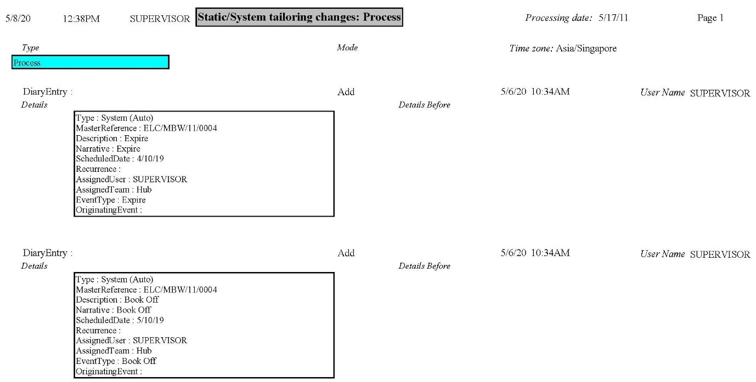

## Overridden Event Warnings/Errors

This report lists entries from the journal file showing changes made to Trade Innovation system tailoring or static data. You can run the report for a single Trade Innovation user or all users, for a range of dates, and to show information for:

* Validation data on warnings produced during transaction processing which were overridden by the user

For each entry the report shows the following information:

* Details of what has been flagged as overridden, under the column *Type*:
* Master Reference
* One of the followings under column *Mode* to indicate types of event incident:
* Error recorded
* Warning – What was overridden
* The date and time the incident happened
* Who was working on the event

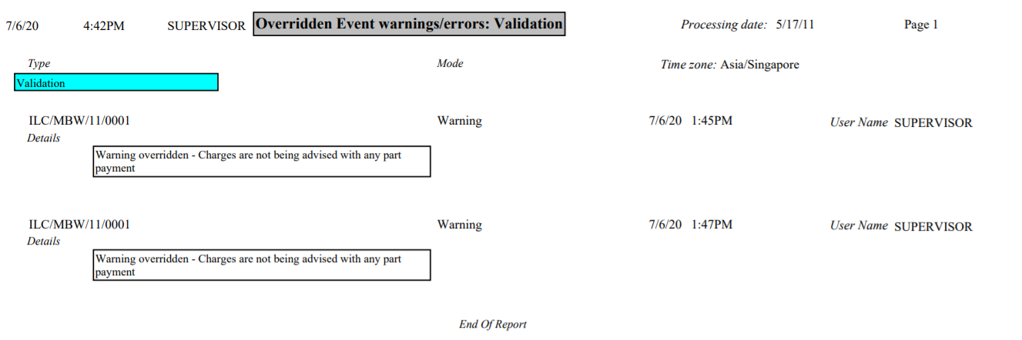

## Batch Steps Run

This report lists batch steps run either manually by a Supervisor or by running end of day processing.

For each entry the report shows the following information:

* Details of what has been run, under the column *Type:*
* Account and deal branch update
* Customer mnemonic update
* Type Name:
* CHANGEDATE
* CLOSING
* FAILUE
* TESTUE
* DLEREBUILD
* RESET_APIS
* PAUSE
* PRUNEASYNC
* One of the followings under column *Mode* to indicate whether the process/batch control is started or ended:
* Start – includes the time when the process/batch control started and what details were changed
* End – includes the time when the process/batch control and what details were changed
* The date and time the batch step was run
* User running the batch step

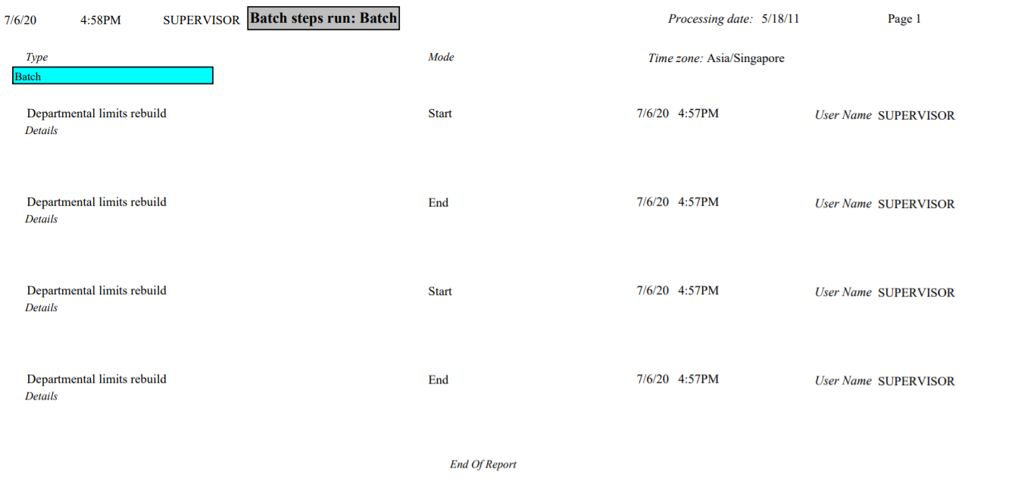

These above three new reports are optional, bank can use either Full Journal report or mixture of the new supplementary reports.

## Diary Exceptions Report

This report produces a list of diary activities that were not carried out when due because of exception conditions. You can run the report to show entries for a particular behalf of branch, product and responsible team; and activities that were due to be carried out within a particular period or before or after a certain date.

Activities are listed within master record within product within team within branch. For each activity, the report shows the following information:

* The master record's reference number and expiry date
* The amount of the master record
* The master record's principal party
* Date and Time the activity failed together with reason text

1. Finastra recommend that you review this report on a daily basis because over time as this grows, processing will take longer

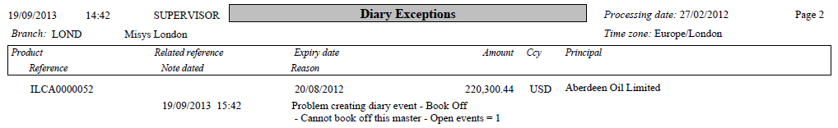

## Interface Details Report

This report produces a listing of the following items passed from Trade Innovation to each back office system:

* Postings
* Projections of future valued funds movements (new and maturity)
* Foreign exchange deals
* Money market deals for finance deals (new and maintenance)
* Repayments of principal against a previously-entered money market finance deal

Items are reported in the order in which they were released to the interface between Trade Innovation and the back office.

You can run the report for all items, or you can run it for items with one of the following statuses:

* Processed
* Unprocessed
* Rejected

For each posting or maturity of a previously-projected item the report shows the following information:

* Whether it is a posting, a projection or a maturity
* The behalf of branch for the transaction in which the item originated
* The master record reference number
* The customer to whom the item relates
* Either a system parameter or charge code indicating the type of account used for the item, or the number of the actual account used, or both
* Where relevant, the number of the back office or external account associated with the account used for the item
* The amount and currency of the item
* A transaction code
* The value date of the item
* The status of the item, 'P' for processed, 'U' for waiting to be processed, 'R' for rejected

For each deal-related item the report shows the following information:

* Whether the item is a foreign exchange deal, FX option take-up, a new money market deal, a maintenance money market deal, or a repayment
* The deal branch for the transaction
* The deal type
* The deal reference number
* The customer to whom the deal relates
* The status of the deal, 'P' for processed, 'U' for waiting to be processed, 'R' for rejected

For a foreign exchange deal or FX option take-up the report also shows:

* The purchase amount and currency
* The sale amount and currency
* The purchase and sale dates
* The exchange rate used

For a money market (MM) deal (if Trade Innovation's Bills financing module is not implemented) the report also shows:

* The deal amount
* The deal start date
* The deal maturity date
* The interest rate used

For a money market maintenance deal (if Trade Innovation's Bills financing module is not implemented) the report also shows:

* The deal amount
* The next interest cycle date - the date up to which accrued interest is to be calculated and posted

For a money market repayment (if Trade Innovation's Bills financing module is not implemented) the report also shows:

* The repayment amount
* The repayment value date

1. Finastra recommend that you review this report on a daily basis.

Examples:

Postings

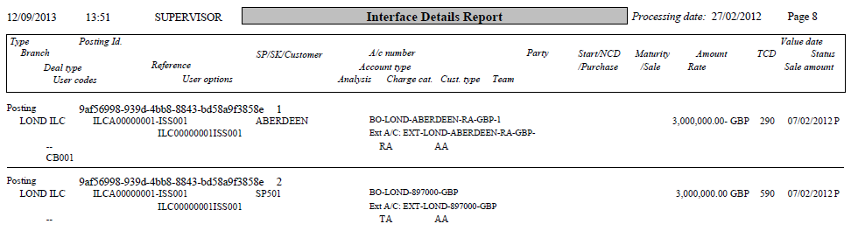

Projections

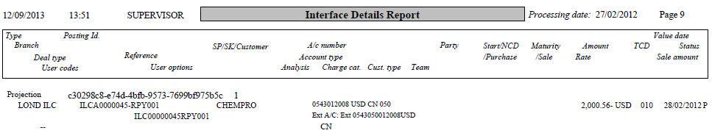

MM deal

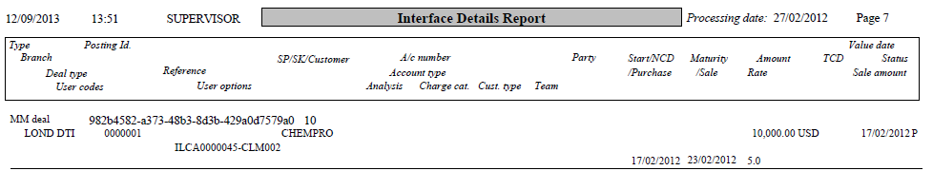

MM Deal Maintenance

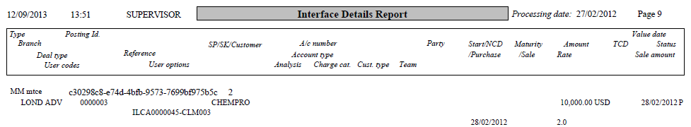

MM Deal Repayment

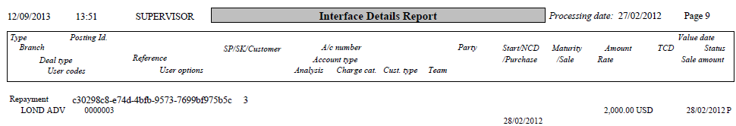

FX deal

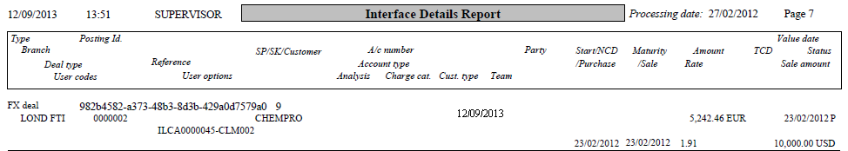

FX Option Deal Take-Up

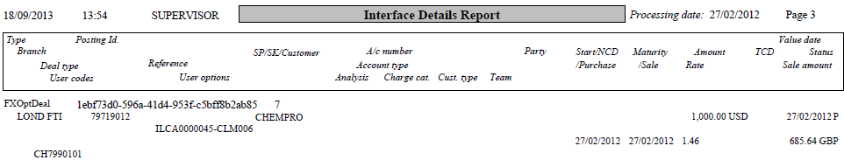

## A/C Postings – Account Report

This report lists all postings posted to an account by value date. This report can be used by your bank as part of its general account reconciliation procedures.

The report allows you to select information for a specific:

* value date or range
* branch or main banking entity
* specific account

The following details are shown for each account:

* Account number
* Account short name
* Customer mnemonic, System parameter or Charge code associated with the account
* Account type and description

The following details are shown for each posting:

* Value date
* Dr or Cr
* Amount and Currency
* Master and event reference

A Net Total line is reported for each value date:

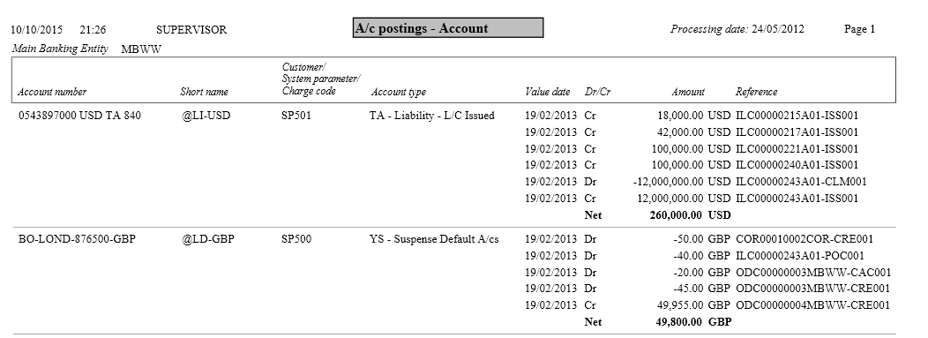

## A/C Postings – Customer/Charge/SP Report

This report lists all postings posted to an account by value date. This report can be used by your bank as part of its general account reconciliation procedures.

The report allows you to select information for a specific:

* value date or range
* branch or main banking entity
* Customer
* Currency
* Account type
* Master reference
* System parameter/Charge code

The report layout is the same as the *A/C Postings – Account* Report:

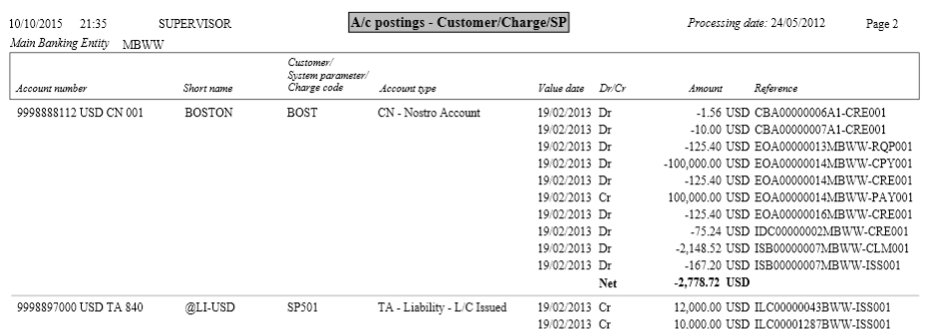

# Departmental Limits Reports

This chapter covers the delivered reports relating to departmental limits. The following table lists these reports, showing for each which product group and category the report can be found under and the number of the page in this Guide on which it is described:

|  |  |
| --- | --- |
| Report Title | Page |
| Limit Categories | View on page 8 |
| Limit Totals | View on page 9 |
| Limit Structure | View on page 10 |
| Limit Setup Report | View on page 11 |
| Country Limits Expiry | View on page 12 |
| Country Utilisation | View on page 13 |
| Customer/Group Limits Expiry | View on page 13 |
| Customer/Group Utilisation | View on page 14 |
| Limit Exception | View on page 15 |
| Utilisation Audit | View on page 16 |

## Limit Categories

This reports lists all the risk categories set up on your system, showing for each:

* The category's unique identifier and description
* Whether or not it is an exclusion category
* The weighting percentage
* Whether or not net credits are to be treated as risk
* The date the category definition was last changed
* The criteria determining which transactions are included as risk within the category

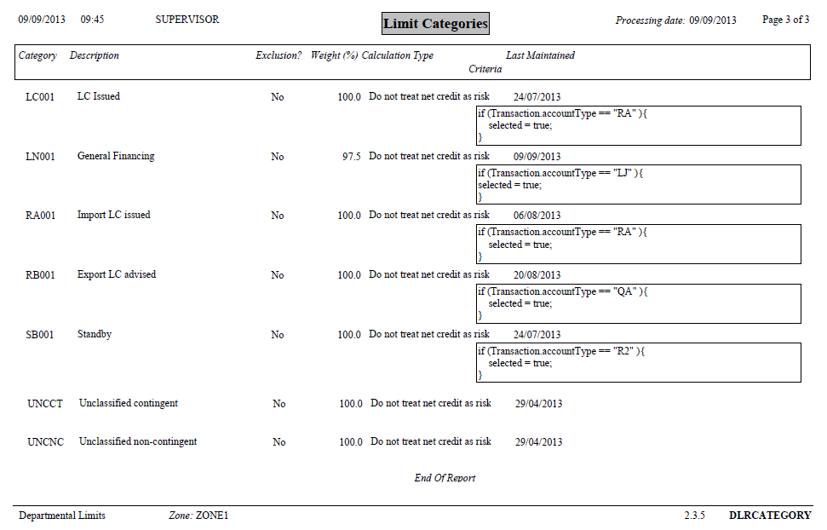

## Limit Totals

This report lists all the total lines set up on your system, showing the categories and total lines included in that total line and the date the total line definition was last changed. For each category or total line, the report shows:

* Whether or not it is a category or a total line
* The unique identifier and description of the category or total line

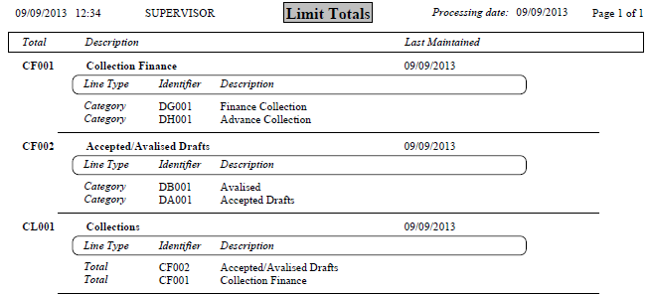

## Limit Structures

This report lists each of the limit structures set up on your system. It shows for each:

* The limit structure's unique identifier and description
* Whether the structure applies to either customers/customer groups or countries or both
* The date the limit structure was last changed
* Each of the category or total lines included in the structure and for each:
* Whether it is a category or a total line
* The unique identifier and description of the category or total
* Whether the category or total line is to be monitored (Y) or not (N)
* Whether the category or total line is to be checked (Y) or not (N)
* Whether the category or total line is to be displayed on reports and enquiries (Y) or not (N)
* Whether the category or total line is to be highlighted on reports and enquiries (Y) or not (N)

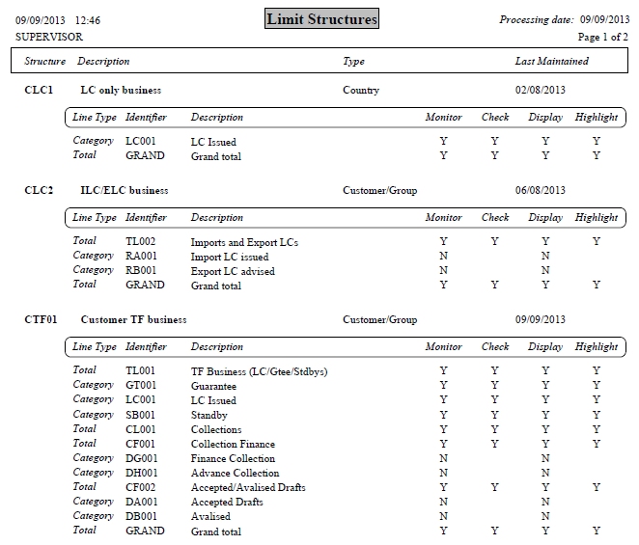

## Limit Setup Report

This report shows details of the limit structures set up on your system. It can be run to show all limits that have been defined or filtered by customer, country and customer group, so that you can use to show the limit structure for (for example) a single customer, country or customer group.

The report shows details of each limit structure for each country, customer and customer group selected (including any default limit structures covered by the selection criteria).

It shows for each:

* The limit structure's unique identifier and description
* Whether it is to be checked (Y) or not (N) by default
* Its default expiry date
* Its currency
* The responsible branch
* Whether the Report in 000's flag is set (Y) or not (N)

It then lists each of the category or total lines included in the structure and shows for each:

* Whether it is a category or a total line
* The unique identifier and description of the category or total
* Its expiry date
* Whether the customer, customer group or country is permitted to trade in this category of risk (Y) or not (N)
* Whether the category or total line is to be checked (Y) or not (N)
* The status of the category or total line

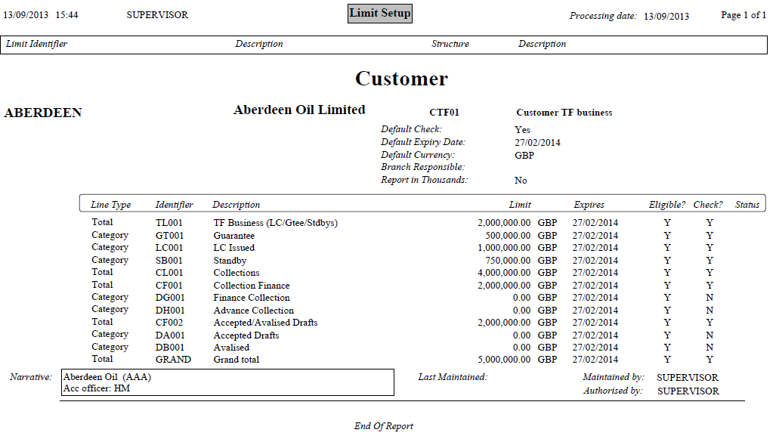

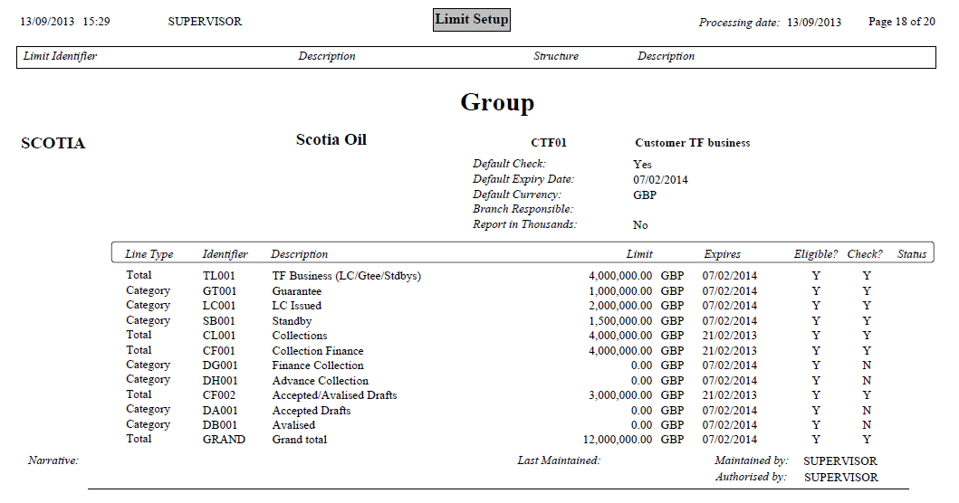

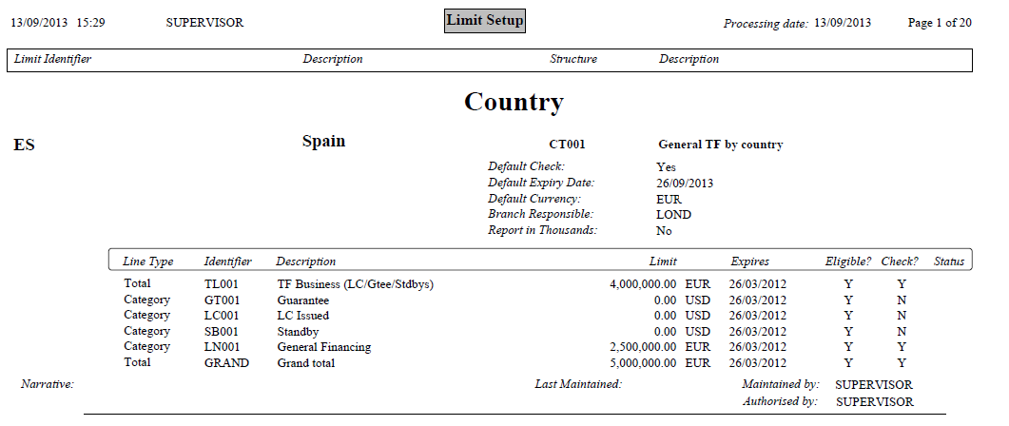

## Country Limits Expiry

The Country Limits Expiry report shows country limits that are due to expire within a specified period of time or which have already expired. You can use the selection to restrict the report to those limits that are due to expire within a specified number of days.

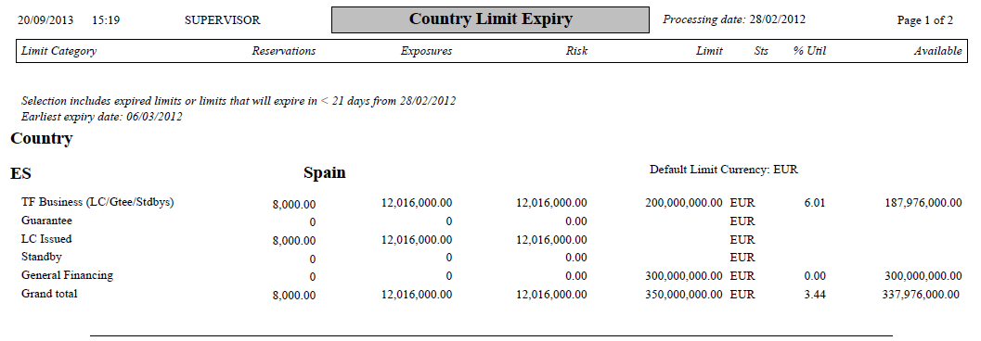

## Country Utilisation

The Country Utilisation report shows the limit utilisation for all countries or a selected country. By default, information is show in the default limit currency for the country.

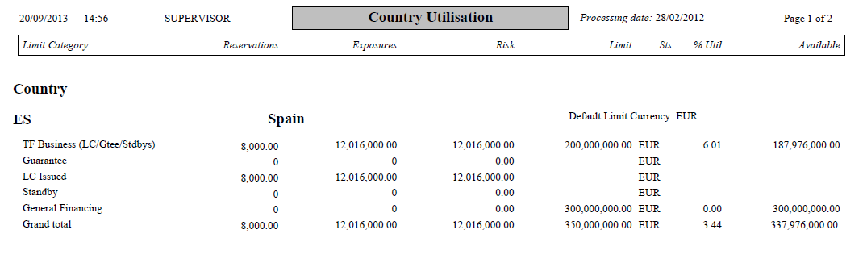

## Customer/Group Limits Expiry

The Customer/Group Limits Expiry report shows customer and customer group limits that are due to expire within a specified period of time or which have already expired.

You can use the selection to restrict the report to either customers or groups (or both) that is due to expire within a certain number of days.

The report includes:

* Customer or Group mnemonic and full name
* Default limit currency ( or reporting currency) if specified
* For each category:
* Category
* Reservations
* Exposures
* Risk amount
* Limit amount
* Status
* % utilisation
* Available amount
* Grand total

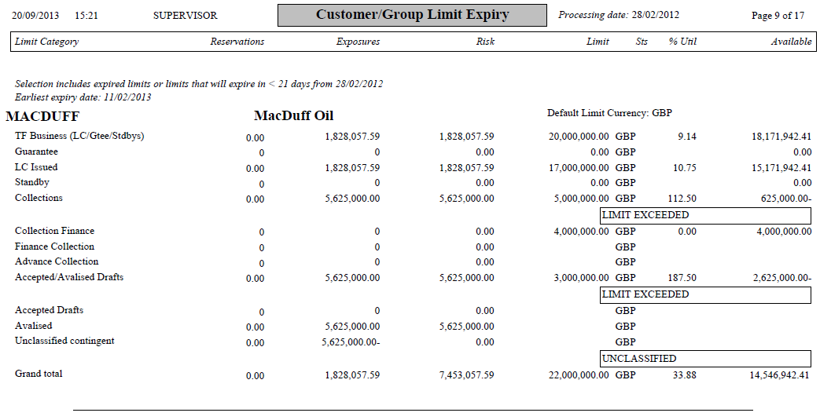

## Customer/Group Utilisation

The Customer/Group Utilisation report shows the limit utilisation for selected customers and their customer groups. It can be run to show:

* Specific customer
* Specific group
* All customer
* All groups
* All customers and groups

By default information is shown in the default limit currency for the customer or customer group.

The report includes:

* Customer or Group mnemonic and full name
* Default limit currency ( or reporting currency) if specified
* For each category:
* Category
* Reservations
* Exposures
* Risk amount
* Limit amount
* Status
* % utilisation
* Available amount
* Grand total
* Example - Group

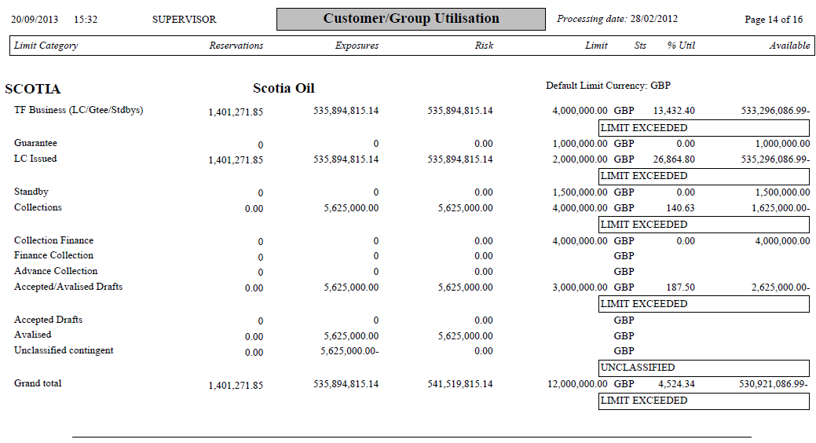

## Limit Exception

This report shows details of customer, customer group and county limits that were exceeded as a result of the overnight cycle's re-categorisation and revaluation processes.

The data shown in this report is cleared daily during the rebuild process.

The report has no filter fields.

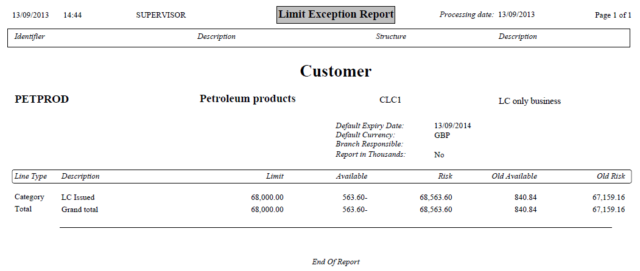

## Utilisation Audit

The Utilisation Audit report shows:

* All exposures and reservations in each category for all customers, customer groups and countries.
* At the end of each category the risk, limit, available amount and utilisation percentage are shown.

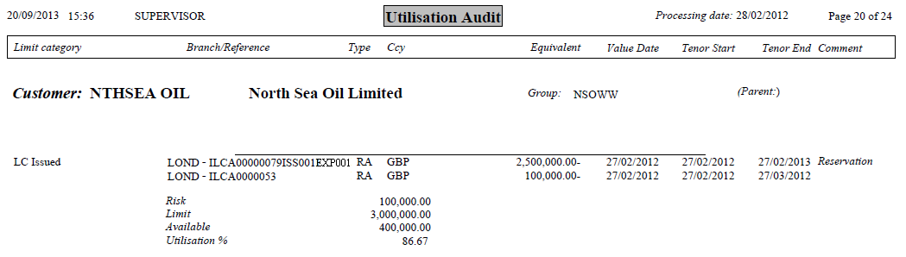

# Financing Reports

This chapter covers the delivered reports relating to transaction processing for financing. The following table lists these reports, showing for each which product group and category the report can be found under and the number of the page in this Guide on which it is described:

|  |  |  |  |
| --- | --- | --- | --- |
| Report Title | Product Group | Category |  |
| Financing Interest Accruals | Financing | Customer management | See below |

## Financing Interest Accruals

This report shows details of interest accruals to date for financing transactions, showing for each the interest earned to date. You can select to show information for a particular branch, product, product type, business area and customer, and between specific start dates and maturity dates.

Information is ordered by financing transaction within deal currency within product type within behalf of branch. For each financing transaction the report shows the following information:

* The financing transaction's reference number
* The start date
* The maturity date
* The interest rate followed by the interest type
* Interest days basis
* The amount outstanding
* The amount of interest earned
* The amount of overdue interest earned
* Whether or not the interest is shared
* The number of days the interest has accrued
* The number of days remaining to accrue
* The number of days past due
* The total interest amount

By deal currency:

* The total interest earned
* The total interest unearned
* The total overdue interest earned

The report provides totals for each currency for each product type, product, and branch. All totals are in the reporting currency if one is specified, otherwise in base currency.

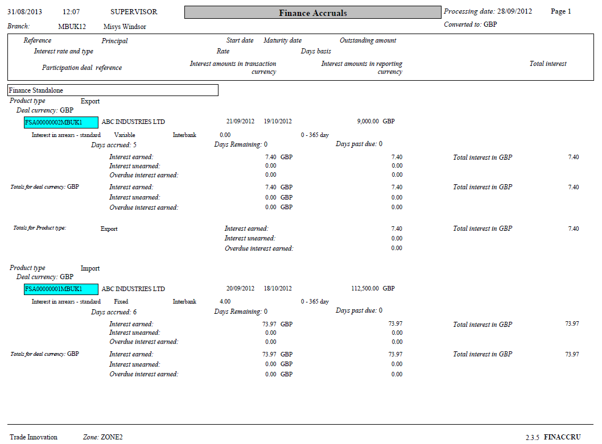

# General Transaction Processing Reports

This chapter covers the delivered reports relating to general transaction processing. The following table lists these reports, showing for each which product group and category the report can be found under and the number of the page in this Guide on which it is described:

|  |  |  |  |
| --- | --- | --- | --- |
| Report Title | Product Group | Category |  |
| Activity Report | General | Production management | View on page 20 |
| Credit Approval History | General | Credit risk management | View on page 21 |
| Master Event History | General | Production management | View on page 22 |
| Our Charge Details | General | Production management | View on page 24 |
| Our Charges by Customer | General | Business analysis | View on page 25 |
| Our Charges by Master | General | Business analysis | View on page 26 |
| Outstanding Activity | General | Business analysis | View on page 26 |
| Outstanding Liability | General | Customer management | View on page 27 |
| Outstanding Transactions by Gateway Customers | General | Customer management | View on page 28 |
| Outstanding Transactions Awaiting Approval | General | Credit risk management | View on page 29 |
| Outstanding Transactions by Non-principal | General | Customer management | View on page 29 |
| Outstanding Transactions by Principal | General | Customer management | View on page 29 |
| Periodic Charge Payment | General | Production management | View on page 31 |
| Periodic Charges | General | Production management | View on page 32 |

## Activity Report

This report produces information for a single master record or for all master records, showing what events have been initiated for each master record and the status of the current active steps for each event within it. You can select information for a particular branch, business area, product, team, master status, event and event status. You can further select information for events that were updated within a particular period or before or after a certain date.

Events are listed chronologically within master record, and master records are ordered within team within behalf of branch.

For each master record, the report shows the name of the product, the master record's reference number, and the names of the principal and non-principal parties to the master record. For each event it shows the following information:

* The event's short name and reference number
* The current active steps for that event and their statuses
* The date and time the event was started
* The amount of the event
* The user who input or last continued the current active steps
* The date that an active step of the event was last amended

Details for transfer letters of credit are shown as details against the parent letter of credit, not in their own right. Back-to-back letters of credit details are given against the related export letter of credit and as import letters of credit in their own right.

Related references are listed for each master that has one or more associated financing transaction, transfer letter of credit or back-to-back letter of credit.

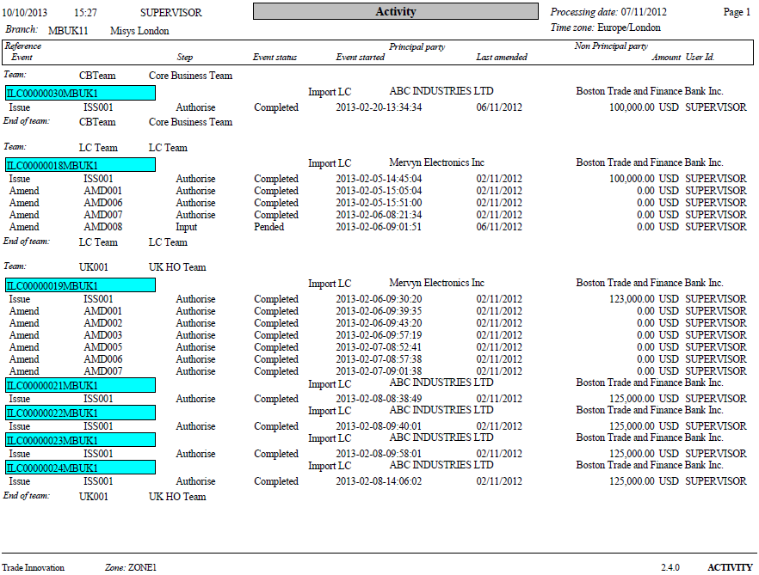

## Billed Charges

This report lists details of all transaction charges that are to be billed externally, where your bank interfaces to an external Fees and Billing system. The report can be run to show information for specific customers and includes the following information:

* The customer
* The charge type
* The amount
* The currency
* The event reference

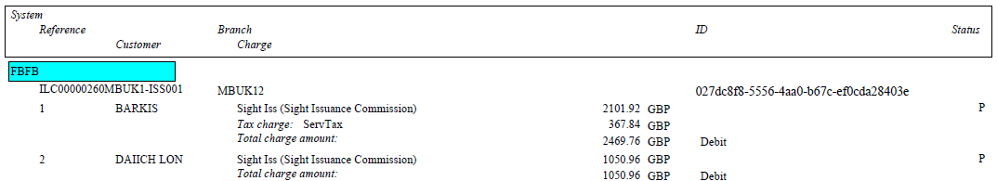

## Credit Approval History

This report lists all transactions that have a credit approval status action under limit checking in their step history. The report can be run to show information for a particular period only and to show information for a particular master record, branch, business area, product, event and master record status.

Information is sorted by product type within product within team within branch. For each master record, the report includes the following information:

* The branch
* The team
* The product
* The product type
* The principal party
* The non-principal party
* The master record's reference
* The event's reference
* The limit check step
* The approval amount
* The user ID of the approver
* The date and time approval was entered
* The account officer
* Any notes entered at the time of approval/rejection

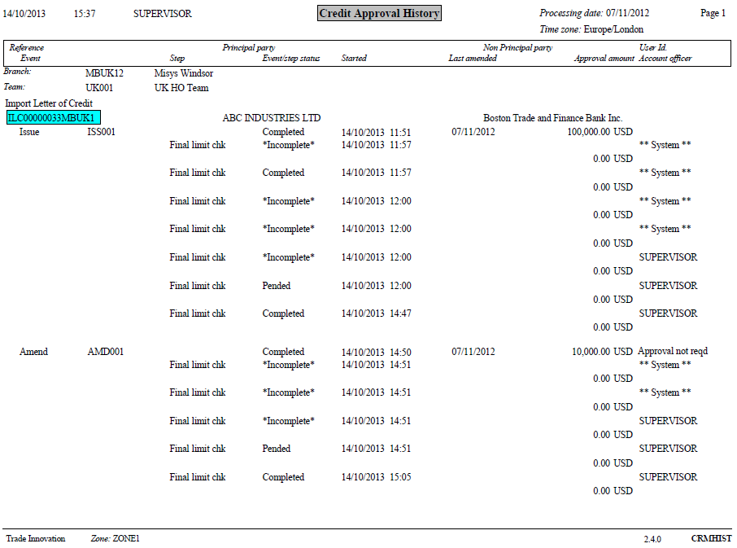

## Master Event History

This report produces a full history of the events for a single master record or for all master records. You can select to run the report for events that were updated within a particular period or before or after a certain date.

Events are listed chronologically by the date and time they were started, and are ordered within master record within behalf of branch. For each master record, the report shows:

* The master record's reference number
* The name of the principal party
* The amount of the master record and its associated currency code
* Its deactivation, book off and expiry dates

For each event it shows:

* The event's short name
* Its prefix
* The date and time it was started
* Its amount, in the currency of the master record (where relevant)
* For events involving amendments, cancellations of payment, the action taken within that event
* The status of the event
* The event's current active steps and their statuses
* The expiry date

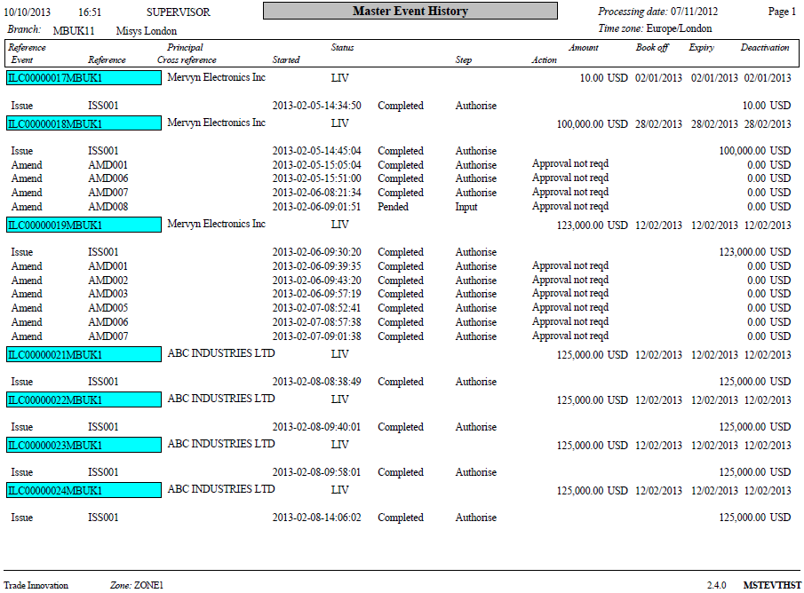

## Our Charges Details

This report is an expanded version of the Our Charges by Master Report. It gives a more detailed analysis of your bank's individual charges for each event. The report can be run for a single master record or for all master records. You can select to show information for a particular branch, product, team, business area and charge status. You can also select to show only those charges that have been billed.

The report has a line for each charge. Charges are listed within master record, ordered by status within customer the charges are due from within event. Master records are ordered within product within behalf of branch. For each charge, the report shows the following information:

* The party paying the charge
* The status of the charge
* A description of the charge
* Whether or not the charge is shared
* The event reference
* Where relevant, the reference of the event in which the charge originated
* The charge basis amount
* The charge amount
* The amount to collect
* The amount of tax and the tax payer (if relevant)
* The charge amount in the reporting currency if one is specified, otherwise in local currency

The report provides totals for each master record and each branch in the reporting currency if one is specified, otherwise in local currency.

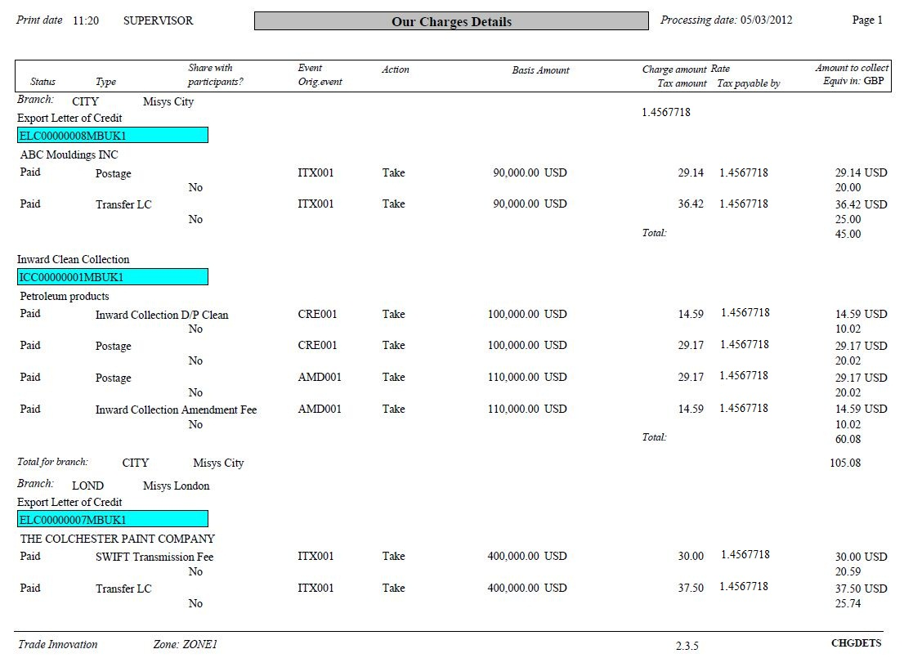

## Our Charges by Customer

This report produces a list of charges by the customer paying the charges. It can be run for a single customer or for all customers. You can select to show information for a particular branch, product and business area.

Information is ordered by master record within product within behalf of branch within customer. For each master record, the report includes the following information:

* The master record's reference number
* Charges paid by the customer
* Charges claimed by the customer
* Charges outstanding or awaiting reimbursement
* Charges with a status of 'Billed'
* The total of paid, claimed and outstanding charges for that customer for the master record

The report includes totals for each product for each customer, for all products for each customer, and for each branch, with grand totals at the end of the report. All amounts are shown in the reporting currency if one is specified, otherwise in local currency.

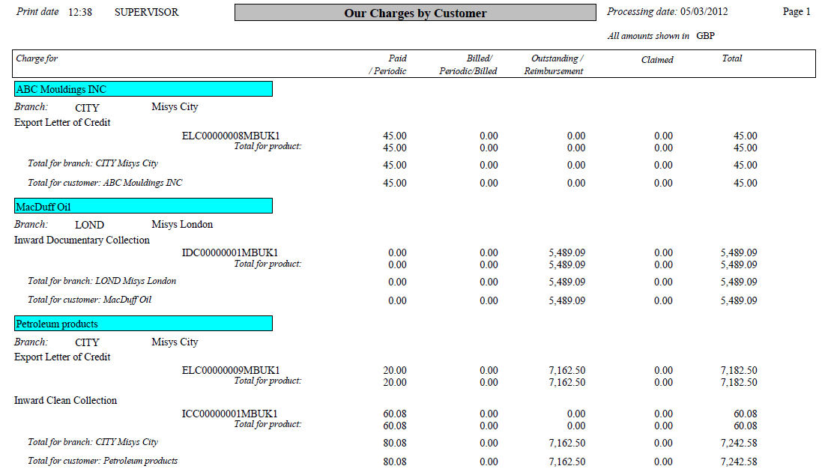

## Our Charges by Master

This report produces a list of charges by master record. It can be run for a single master record or for all master records. If run for all master records, you can select to show information for a particular branch, product, team, and business area.

Transactions included in the report are ordered by reference number within product within behalf of branch. For each master record, the report shows the following information:

* The master record's reference number
* Charges paid by the customer
* Charges claimed but not yet paid by the customer
* Charges outstanding
* Charges with a status of 'Billed'
* The total of paid, claimed and outstanding charges for the master record

All amounts are shown in the reporting currency if one is specified, otherwise in local currency.

The report includes totals for each product and branch, with grand totals at the end of the report.

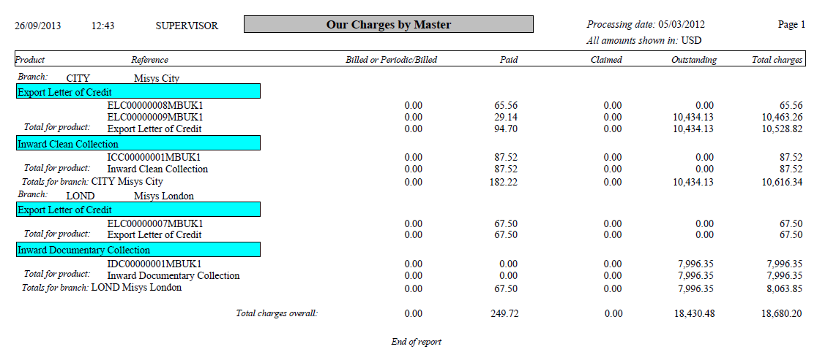

## Outstanding Activity Report

This report produces a list of all master records that have not yet been cancelled or booked off. You can run the report to show information for a particular product, product type, branch, business area and team.

Additionally an expiry date range can be specified.

Your bank can also configure this report so that user-definable field values can be used as selection criteria.

Master records are listed by reference number within product type within each product within team within behalf of branch. For each master record, the report shows the following information:

* The product
* The product type
* The master record's reference number
* The name of the principal party for the master record
* The amount of the master record
* The available amount
* The liability
* The expiry date of the master record (where available)
* If relevant, the references of any related masters

Totals are provided for each product, team and branch, with grand totals of outstanding business at the end of the report. Amounts and totals are in the reporting currency if one is specified, otherwise in base currency.

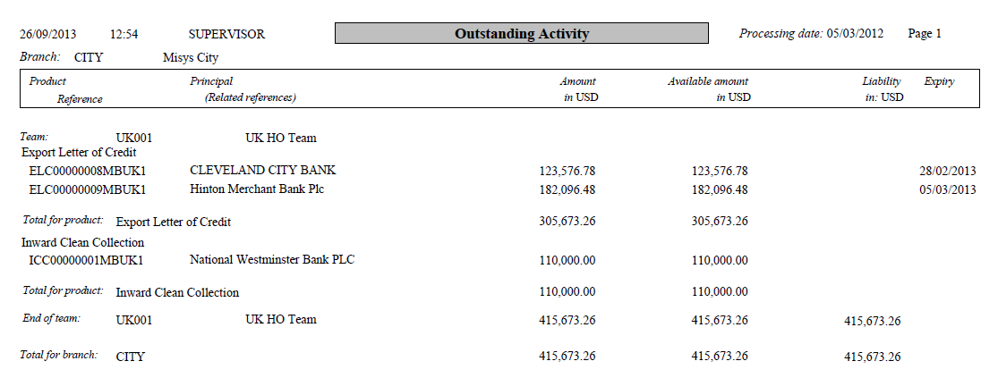

## Outstanding Liability

This report shows totals for outstanding liability for either a particular customer or bank or all customers or banks, or for a particular country or all countries, or for a particular customer group or all customer groups.

In addition to the summary view it is possible to request a ‘Complete’ view that shows each transaction that contributes to the liability totals as well as the summary at the end of the report. Use the ‘Format’ field in the report selections to select the view required. The default is to show the ‘Summary’ view.

Use the Option field to select:

* 'Customer' to run the report to show information for one or all customers/banks. This is the default if no option is selected
* 'Country' to run the report for one or all countries
* 'Parent group' to run the report for one or all customer groups

The report shows the total amount of outstanding liability for each customer/bank, country or customer group included in the report, with sub-totals by product. Figures are shown in base currency, with conversion carried out using the spot rate.

Summary view format:

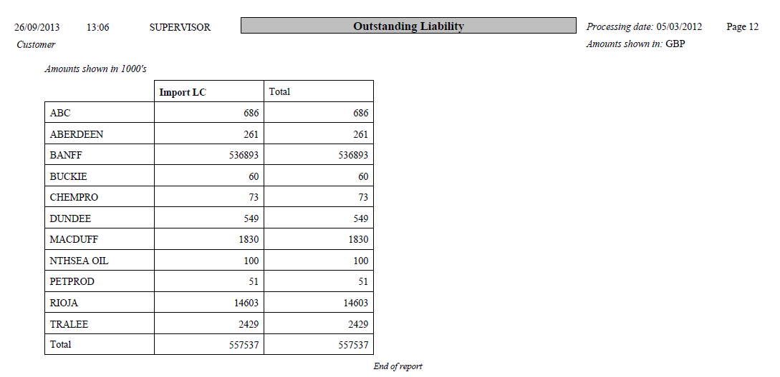

Complete view format:

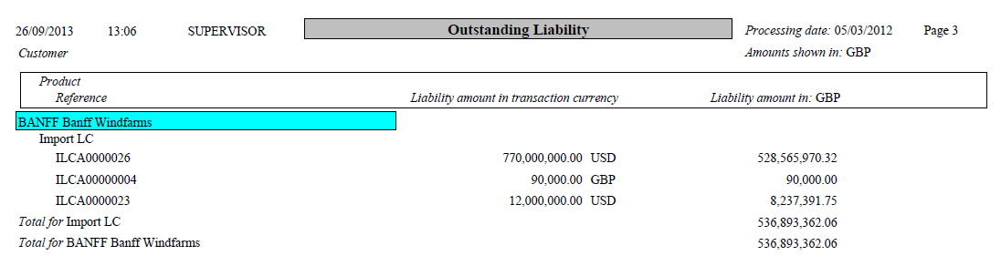

## Outstanding Transactions by Gateway Customer

This report lists information for master records that are not yet booked off or cancelled. The report will list only those transactions relating to customer gateway customers. You can select information for a particular branch, business area, product, product type or gateway customer. You can further select information for master records that were updated within a particular period or before or after a certain date.

The report includes the following information:

* Behalf of branch
* Principal party name – identifier and country
* Product
* For each product:
* Master status
* Reference
* Related master party
* Available amount and currency in base currency
* Available finance amount in transaction currency
* Transaction amount
* Contract Date
* Next Revolve Date
* Expiry Date

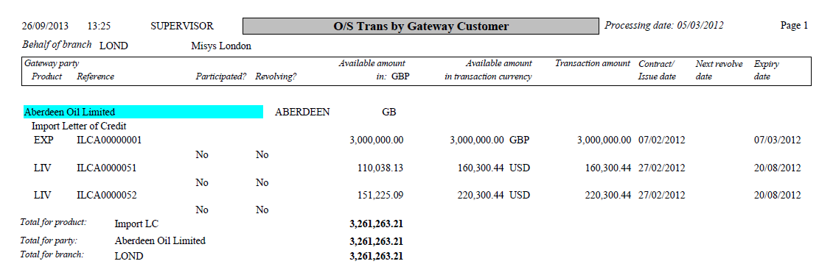

## Outstanding Transactions Awaiting Approval

This report has the same layout, reporting options and content as the Activity Report, but has an additional filter to limit the report to transactions awaiting credit approval only.

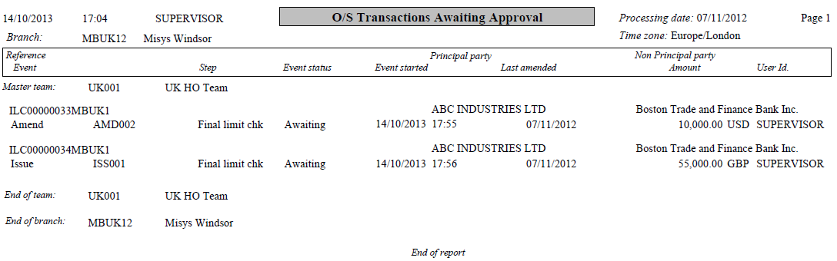

## Outstanding Transactions by Non-principal

This report has the same layout, reporting options and content as the Outstanding Transactions by Principal report, but shows information for non-principal parties instead of principal parties. All totals are in the reporting currency if one is specified, otherwise in base currency.

## Outstanding Transactions by Principal

This report allows you to list information for master records that are not yet booked off or cancelled. You can run the report to show information for a particular branch, product, product type, business area and principal party; and to show only those master records that expired within a certain period or before or after a certain date.

Information is ordered by product within customer within behalf of branch. For each master record, the report includes the following information:

* The master record's reference number, followed where relevant by the product type
* The available amount in the reporting currency if one is specified, otherwise in base currency
* The available amount in the transaction currency
* The master record amount
* The date the master record was created
* The master record's expiry date
* The reference of any related transaction

The report includes totals for each product for each principal party, for all products for each principal party, and for each branch, with grand totals at the end of the report. All totals are in the reporting currency if one is specified, otherwise in base currency.

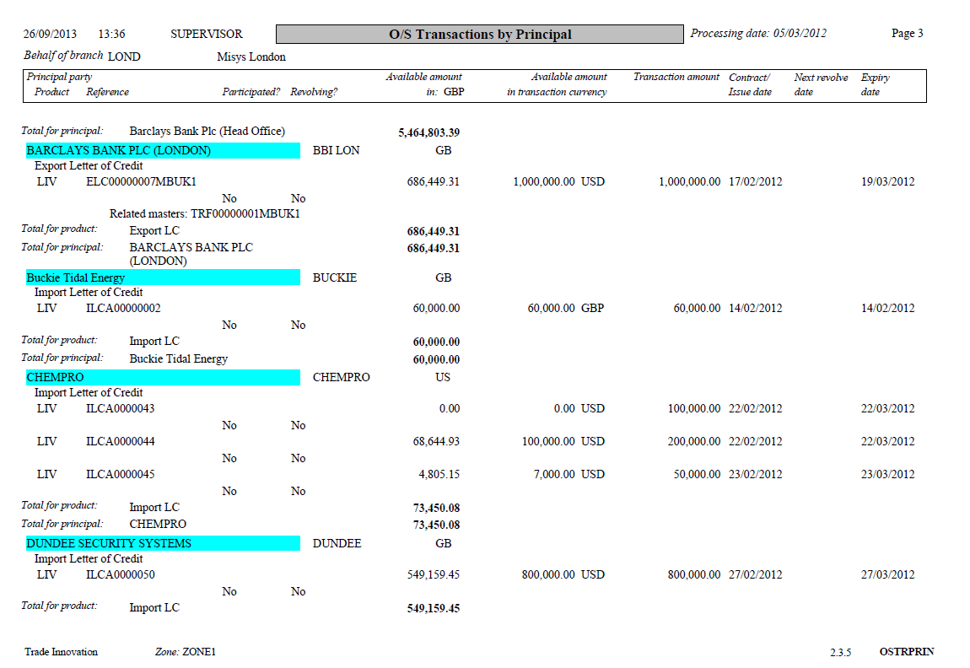

## Periodic Charge Payment

This report lists all transactions which have a Pay Charges event within a period that you can specify. You can run the report for a single master or for all masters. You can select to show information for a particular branch, product, business area, master status, customer, currency, or team.

Transactions are ordered by customer within team within date of the Pay Charges event. For each transaction reported on the report shows the following information:

* The names of the principal and non-principal party
* The date of the Pay Charges event
* The projected total of the charges to be included in that event
* The total amount accrued or amortised to date
* Whether the charge amount is payable or receivable
* The daily amount accrued or amortised
* The transaction reference
* Any related reference

The current amount available on the master

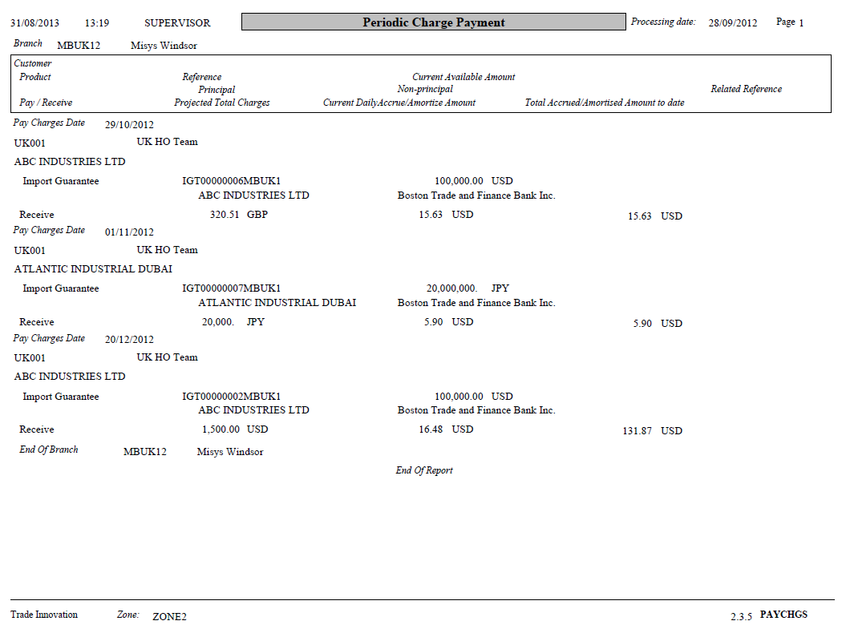

## Periodic Charges

This report lists all transactions which have not yet expired and which have periodic charges either accruing or amortising within a period that you can specify. You can run the report for a single master or for all masters. You can select to show information for a particular branch, product, business area, master status, customer, currency, or team.

Transactions are ordered by customer within team within behalf of branch. For each transaction reported on the report shows the following information:

* The name of the charge payer/receiver
* Whether the charge is accruing or amortising
* Whether or not the charge is shared
* The total amount accrued or amortised to date
* The daily amount accrued or amortised
* The transaction reference
* Any related reference
* The current amount available
* Whether the charge amount is payable or receivable

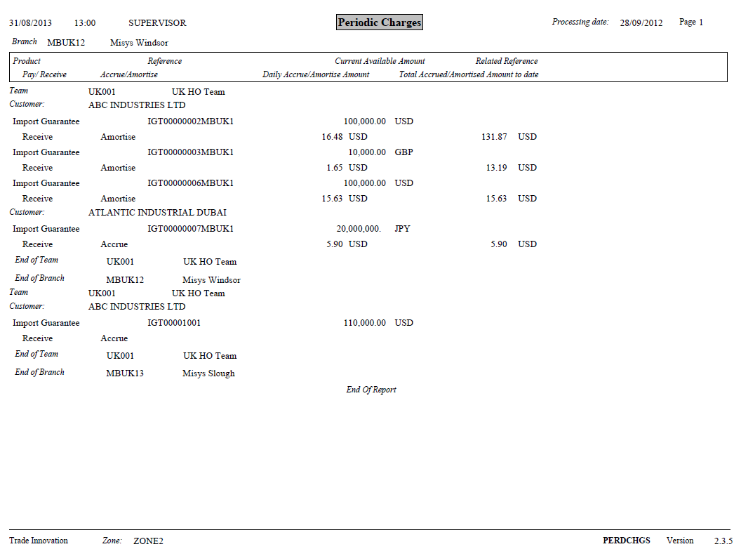

# System Tailoring Reports

This chapter covers the delivered reports relating to static data maintenance. The following table lists these reports, showing for each which product group and category the report can be found under and the number of the page in this Guide on which it is described:

|  |  |  |  |
| --- | --- | --- | --- |
| Report title | Product group | Category |  |
| System Tailoring Report | General | System tailoring | View on page 33 |

## System Tailoring Report

This report is designed to present rules conditions and parameter code details.

This report can be run to include all or just one of the following types of information:

* Clauses
* Charges
* Documents
* Postings
* Tracers
* Review/authorisation settings
* Bank-defined errors and warning messages
* Service level agreements
* Event orchestrations
* Teams
* Payment actions

The report can be run to show information for all products and events, or for a particular product and event.

Information is ordered by type ID within type within event within product. For each entry, the report shows the following information:

* The ID and description of the item
* If the item is a charge, whether it is an amendment charge
* For documents, whether the event is to be used to determine the method of transmission
* Whether the item applies to the event or other attachments, such as draft
* For charges the charge basis amount field code
* For documents the field code of the addressee or party role
* Whether the item is optional
* The text of any rules that govern when the item is used
* The text of any bank-defined error or warning messages
* For a charge, the charge receive party
* For a payment action type, the default action and behaviour

A flag indicates whether the charge basis amount can be amended or not.

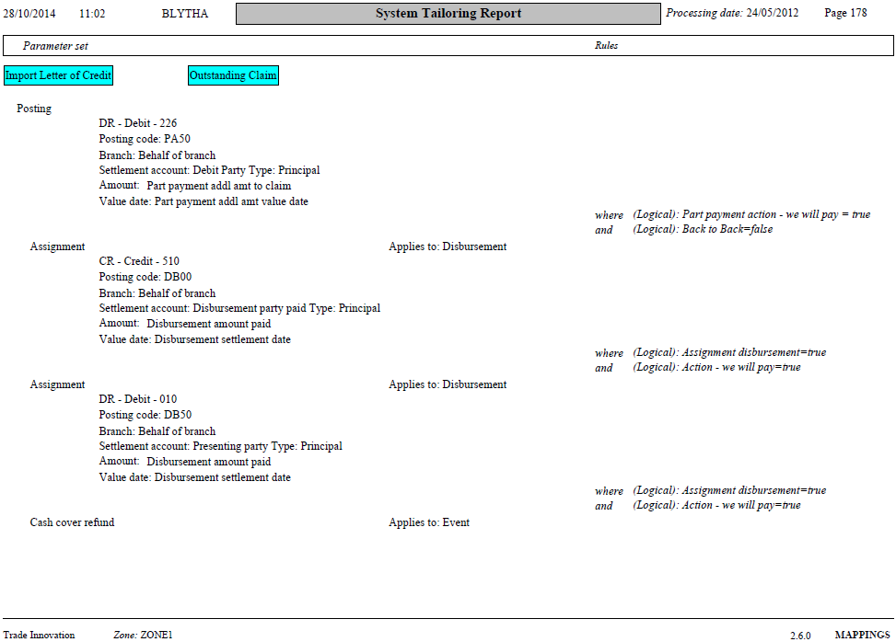

# Watch List Reports

This chapter covers the delivered reports relating to watch list checking. The following table lists these reports, showing for each which product group and category the report can be found under and the number of the page in this Guide on which it is described:

|  |  |  |  |
| --- | --- | --- | --- |
| Report title | Product group | Category |  |
| Watch List - Outstanding Checks | General | Customer management | View on page 35 |

## Watch List - Outstanding Checks

This report lists transactions that have been pended and are awaiting list checking. It will include transactions which have the following list checking actions:

* Check underway
* None required
* Matches overridden
* Disposition awaited
* Transaction to be aborted
* Funds blocked
* Repeat check
* Not initiated

You can run the report to show information for a particular branch, team, master, product or event. You can also filter the report by the date events were started and/or completed, and to show information for transactions with a particular list checking action only.

Transactions are listed by master reference within list checking user action within list checking transaction status; then by the date the event undergoing was started (oldest first) within team within behalf of branch.

The report includes the following information:

* Branch
* Team
* Master reference

For each event it shows:

* Event reference
* Event start date
* List checking narrative

For each party to a transaction that is awaiting list checking it shows:

* Name
* Country of residence
* Parent country
* Country of risk

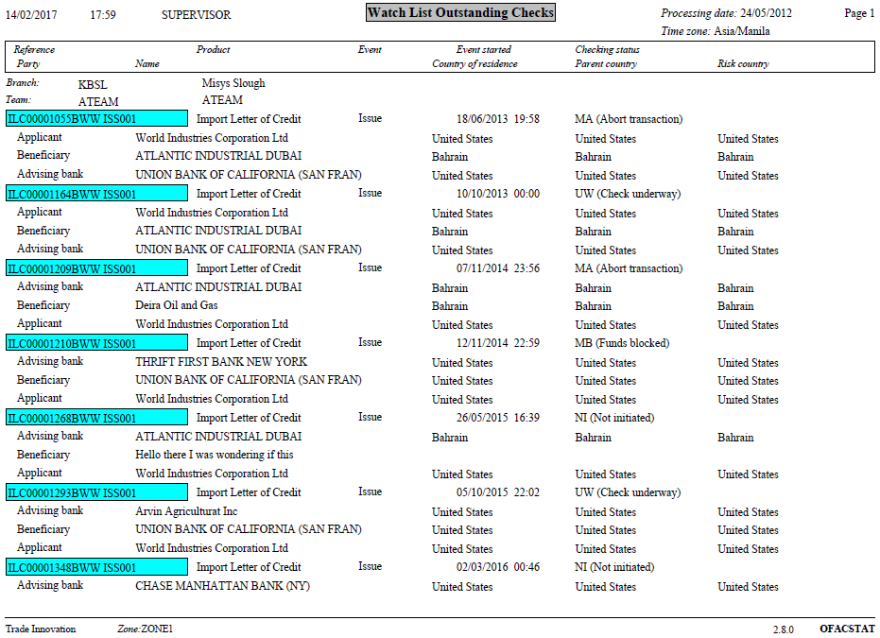

# License Compliance Reports

This chapter covers the delivered reports relating to license compliance. These reports are for use by Finastra support staff to monitor adherence to the licensed products and features at the bank. The following table lists these reports, showing for each which product group and category the report can be found under and the number of the page in this Guide on which it is described:

|  |  |  |  |
| --- | --- | --- | --- |
| Report Title | Product Group | Category | Page |
| VBP Product Categorisation | General | Production management | View on page 37 |
| VBP Product Licensing | General | Production management | View on page 39 |
| VBP Workflow Compliance | General | Production management | View on page 40 |

## VBP Product Categorisation

This provides a table of activity reporting the number of masters made live by the bank, per licensed product group per month.

Pre-advise and provisional events are not included. Transactions subsequently expired, cancelled or booked off are also included.

The report can select transactions by the following parameters

* Master creation events completed from date
* Master creation events completed to date
* Include itemised masters

The itemised masters list reports details on all masters included in the table counts. Transactions are ordered by Our reference, within month initiated, grouped by transaction type group. For each transaction reported on the report shows the following information:

* Our reference
* Current event status
* Date transaction initiated

1. This report is intended for use by Finastra support staff working on-site.

It provides information on the number of transactions initiated by the bank. Information is shown by product per month.

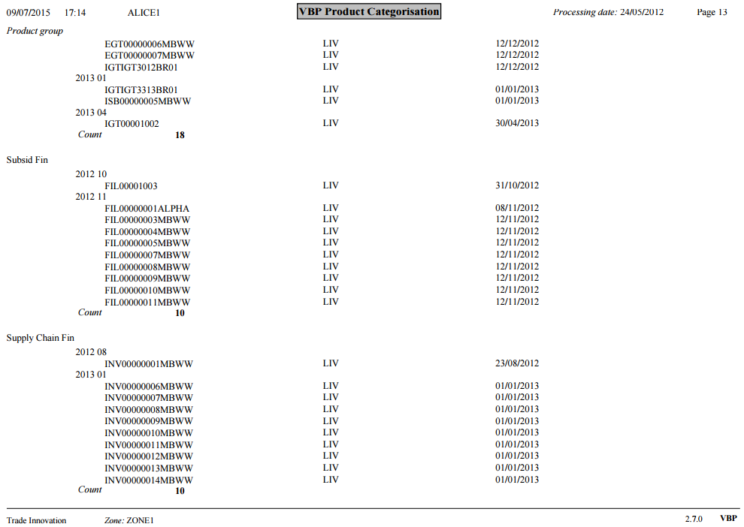

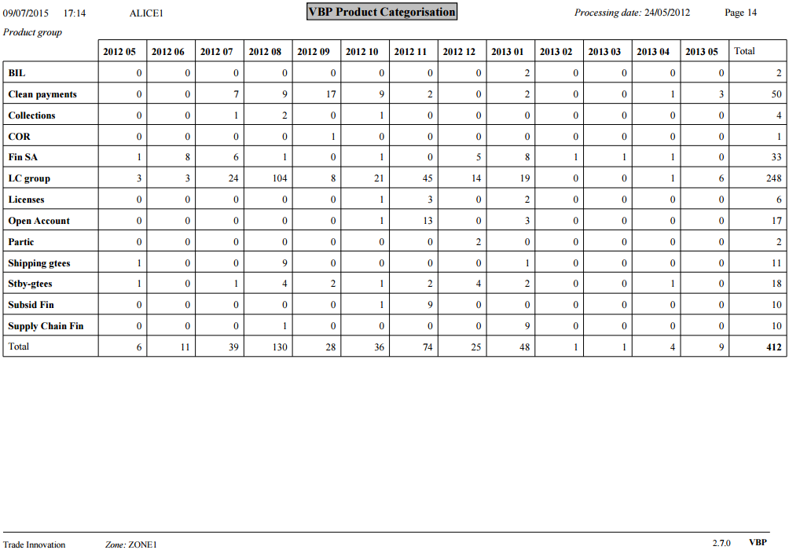

## VBP Product Licensing

This report presents the settings of various features identified from various checks made to settings in the zone or the global application. The following features are checked for:

* Global processing enabled in the zone
* The level of SDK enabled in the zone: Lite, Standard or Advanced
* The level of the SDK customisation project in the zone if implemented: Lite, Standard or Advanced
* If a Proxy zone is defined within the global layer.
* If event status transition notifications are implemented
* If an external system has been defined for the applications lists
* If UI-Control is deployed for customer configuration – (step fields can be set to hide or read only).
* If an external DMS has been defined for the zone

1. This report is intended for use by Finastra support staff working on-site.

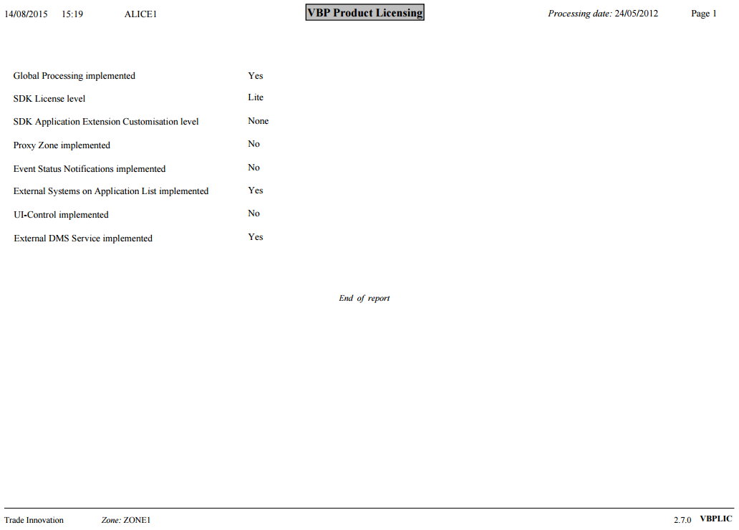

## VBP Workflow Compliance

This report comprises internal data integrity checks against the level of SDK licensed:

* If SDK Standard or Lite is licensed any instances of Advanced SDK steps and templates implemented in the zone are reported.
* If SDK Lite is licensed any instances of Standard SDK steps and templates implemented in the zone are reported.

This report additionally checks for external systems defined on the applications list:

* If SDK Standard or Lite is licensed any instances of external systems defined for the application list.

1. This report is intended for use by Finastra support staff working on-site.

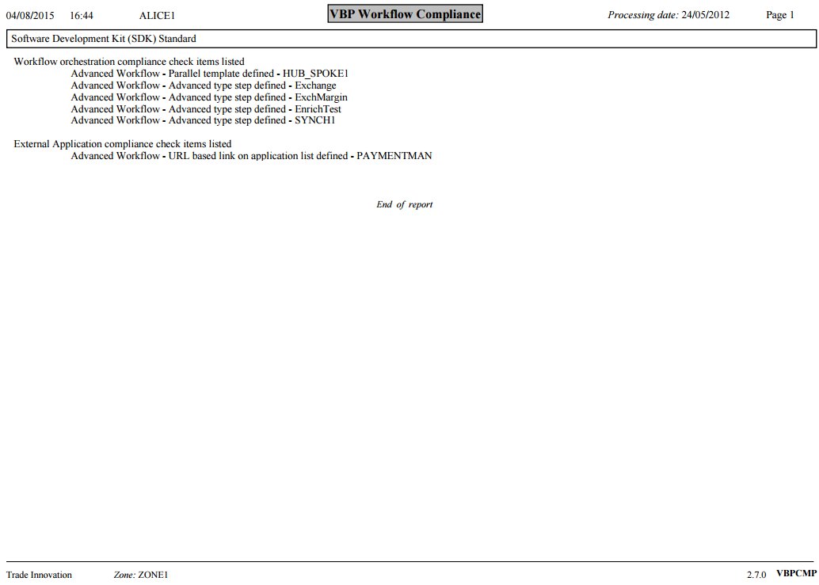

# Export Definitions

The Trade Innovation reporting framework can also execute pre-configured export classes. This is dedicated code, targeting specific data, that will be extracted into files for processing by other systems.

They are defined in the same way as a standard report, and usually will allow selectivity via main banking entity, as export data will usually be split by main banking entity.

The crystal report name does not correspond to a specific crystal report file, it represents a class name in the application configuration, and is differentiated from a crystal report file by the extension ‘.exp’.

They typically would be executed as part of the end of day, and by default would be executed against each main banking entity associated with the processing cycle.

If only a subset of main banking entities needs the export run against them, then separate report profiles must be added, one for each main banking entity that requires it.

The standard processing for an export class would be that the file generated would also be stored in the report DMS.

The format of the files generated is usually fixed in the code, so while there may be an option to define the output format when the report profile is defined, it will not change.

1. Export classes usually have extra assembly configuration options, so make sure those options have been specified prior to defining or running the export

# Running Reports

This chapter provides instructions on running reports.

## Running a Report

Reports are accessed by using the Reports link in the master browser or SLA dashboard when using the transaction processing application, or by using the **Report**|**Run** menu option in other Trade Innovation applications.

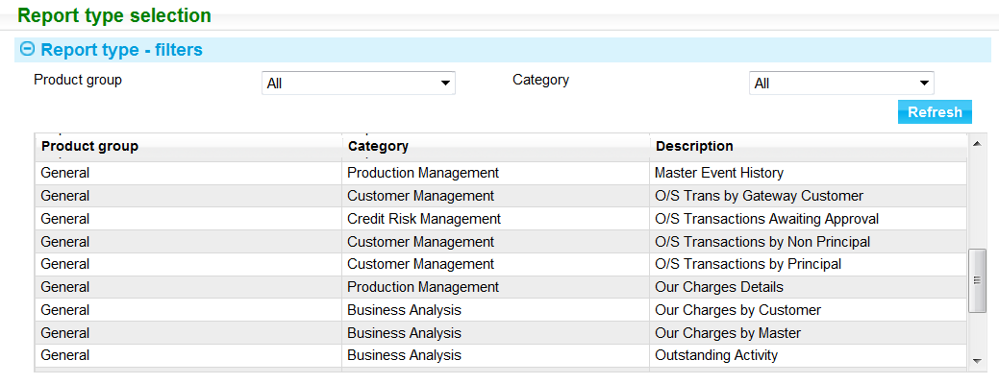

The Product Group and Category fields act as filters, allowing you to display a manageable selection of the reports available. The tables at the beginning of the chapters in this document show what to select in the Product Group and Category fields to run each report. The reports available vary depending on the Trade Innovation application from which you access the window.

The View button allows you to see how a report has been configured (see the Report Tailoring User Guide – Trade Innovation for report configuration). The Run button allows you to run a selected report.

### Setting the Selection Criteria

When you run a report, the system displays a window containing filter fields that you can use to control what information is included in the report. These are shown in the Selection pane. There is a standard set of filter fields, but only those relevant to a particular report are displayed.

The following illustration shows the fields displayed for the System Tailoring Report:

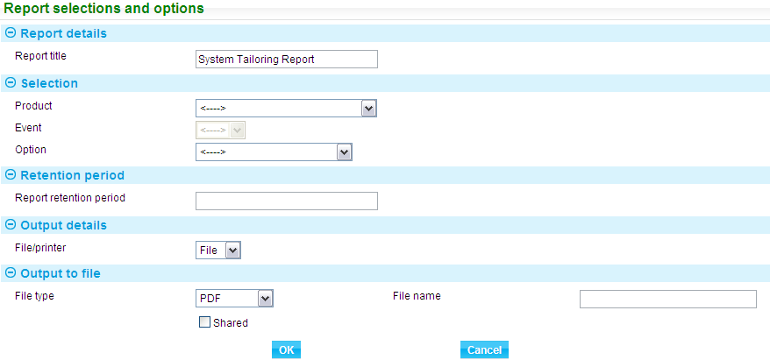

Set the selection criteria and press **Refresh**.

The following table explains what to enter into the remaining fields in this window. The fields are present for all reports:

|  |  |
| --- | --- |
| Field | What to Enter |
| Report Retention Period | The length of time for which the report is to be held on the system before being deleted during overnight processing. |
| File/Printer | Select whether the report is to be written to a file or printed. |
| Reporting Currency | The currency in which the report is to be run. If you leave this blank, base or local currency is used. The choice depends on the particular report selected |
| File Type | If the report is to be written to a file select the file type form the following options:   * Excel * Word * Text * CSV format * PDF * Rich text * RPT |
| File Name | The name to be given to the report. This identifies the report in the window used to monitor print jobs. |
| Shared | Check the Shared field if the file is to be available to users other than yourself. If you check this field, other users will be able to list and view the report in the window used to monitor print jobs. |
| Printer | If the report is to be printed select the printer. Additional fields are displayed that allow you to enter printer settings. The fields displayed depend upon which printer you have selected, but will typically include fields that allow you to enter a page range and the number of copies to be printed. |

Press **OK** to run the report.

The system creates a job for the report on the job queue. You can view all the reports you have submitted to the system using the Jobs link at the top of the screen.



A job number is created for each report request. If the report spools separately for multiple main banking entities, a job number is assigned to each spool request and the description for each report contains the branch ID for the main banking entity. Where a specific branch was selected for reporting that is appended to the report description instead of the main banking entity ID.

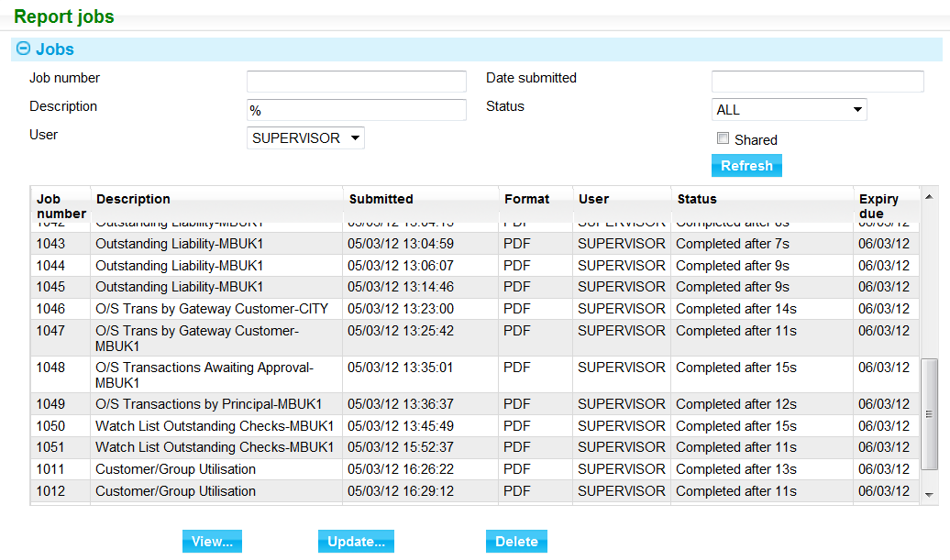

By default, the window shows only those print jobs that you have submitted. Checking the Shared tick box and pressing Refresh lists instead all report jobs submitted with the Shared flag checked.

System administrators are able to view the reports submitted by all users.

The filter fields allow you to restrict the list, and you can click on the headings to sort entries by the information in that column.

Information for each job is shown under the following headings:

|  |  |
| --- | --- |
| Heading | What it Shows |
| Job Number | The number generated for the job by the system. This number provides the name of the file in the directory to which the report job was written. |
| Description | The name of the report, as shown in the list from which you selected the report to run in the system. |
| Submitted | The date and time when you ran the report. |
| Format | The format in which the report was output. |
| User | This is shown only when you are displaying shared reports. It shows the ID of the user who submitted the report job. |
| Status | The status of the job. |
| Expiry Due | The date the report is due to expire. |

### Bank-definable Selection Criteria

The system permits your bank to define up to three fields for each product to be used to restrict what is included in a report. If they exist, these fields are shown once you select a product in the Report Selections and Options window.

There are two selections that allow a drop down list of values to be shown and one where a specific value can be typed in to a text field.

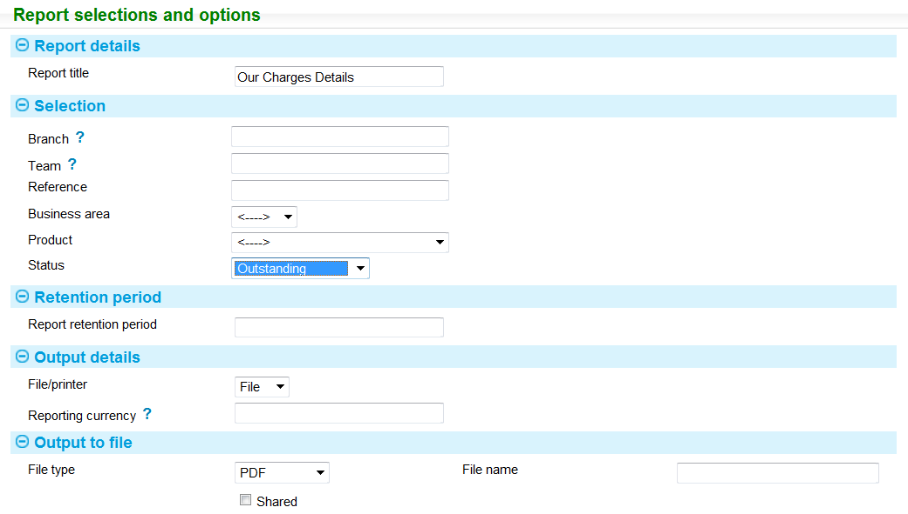

In this example one of the possible three filter fields have been defined. This is labelled Status and contains a list of the charge status such as ‘Paid’, ‘Waived’, ‘Outstanding’.

You can then select from the list values specified for this field. The report will include only those charges that match the selected value.